DATE: 17/07/2024

COURSE CODE: CSA0983

ASSIGNMENT – 3

1. Write java Program for Consider a scenario, Bank is a class that provides functionality to get rate

of interest. But, rate of

interest varies according to banks. For example, SBI, ICICI and AXIS banks could provide 8%,

7% and 9% rate of interest.(Method Overriding)

Program:

class Bank {

public double getRateOfInterest() {

return 0;

}

}

class SBI extends Bank {

@Override

public double getRateOfInterest() {

return 8.0;

}

}

class ICICI extends Bank {

@Override

public double getRateOfInterest() {

return 7.0;

}

}

class AXIS extends Bank {

@Override

public double getRateOfInterest() {

return 9.0;

}

}

public class Main {

public static void main(String[] args) {

Bank sbi = new SBI();

Bank icici = new ICICI();

Bank axis = new AXIS();

System.out.println("SBI Bank Interest Rate: " + sbi.getRateOfInterest() + "%");

System.out.println("ICICI Bank Interest Rate: " + icici.getRateOfInterest() + "%");

System.out.println("AXIS Bank Interest Rate: " + axis.getRateOfInterest() + "%");

}

}

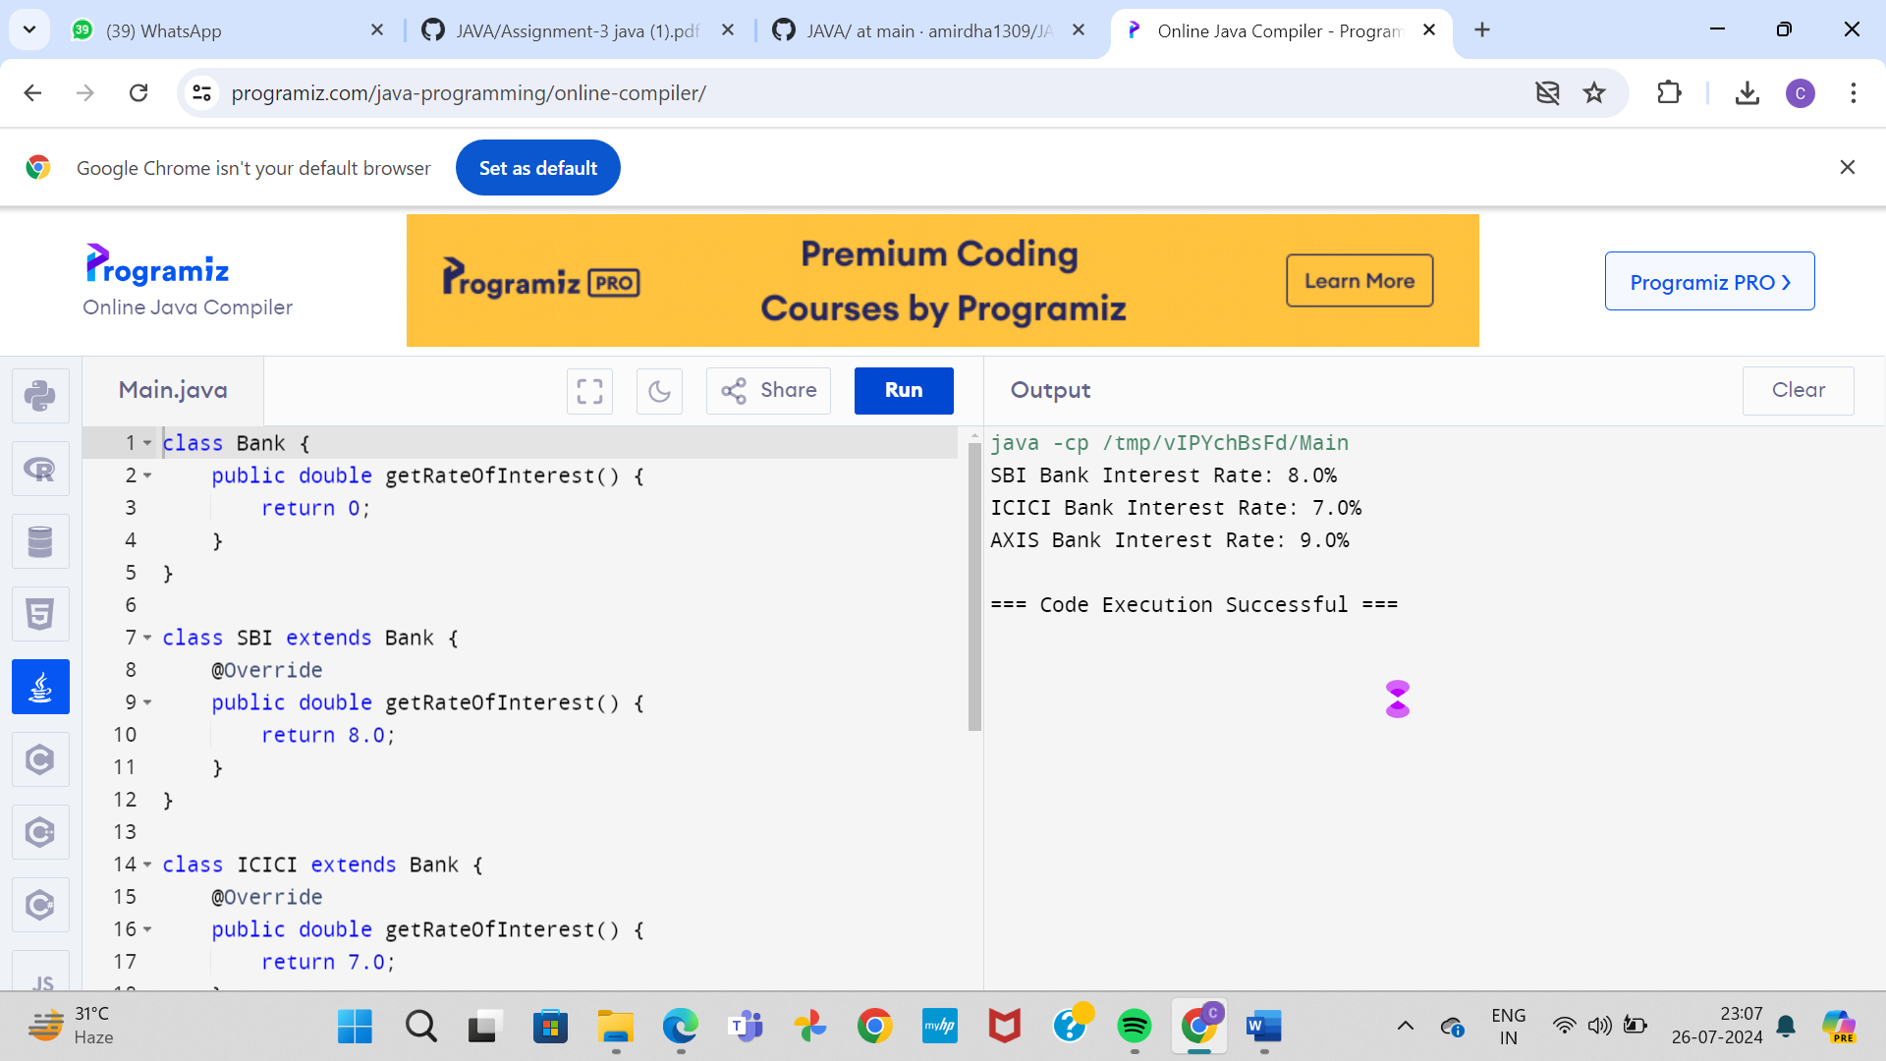

2. Develop a JAVA code to display the balance. Include the following members:

• Design a class to represent a bank account.

• Data Members: Name of the depositor, Account number, Type of

account(Savings/Current), Balance amount in the account(Minimum balance is Rs.500.00)

• Methods:

1.

2.

3.

To read account number, Depositor name, Type of account.

To deposit an amount (Deposited amount should be added with it)

To withdraw an amount after checking balance(Minimum balance must be Rs.500.00

Note : Assume that balance amount = 10000

Test Cases

1. 100, Raja, S, 8000

2. Raja, 100, S, 9000

3. 101, Rani, S, 12000

4. 102, Ragu, W, 8000

5. 103, Ravi, C, 10000

Program:

import java.util.Scanner;

class BankAccount {

private String depositorName;

private int accountNumber;

private String accountType;

private double balance;

public void readAccountDetails() {

Scanner scanner = new Scanner(System.in);

System.out.print("Enter account number: ");

accountNumber = scanner.nextInt();

scanner.nextLine();

System.out.print("Enter depositor name: ");

depositorName = scanner.nextLine();

System.out.print("Enter account type (Savings/Current): ");

accountType = scanner.nextLine();

}

public void deposit(double amount) {

balance += amount;

System.out.println("Amount deposited successfully.");

}

public void withdraw(double amount) {

if (balance - amount < 500) {

System.out.println("Insufficient balance. Minimum balance should be Rs.500.00");

} else {

balance -= amount;

System.out.println("Amount withdrawn successfully.");

}

}

public void displayBalance() {

System.out.println("Account Details:");

System.out.println("Depositor Name: " + depositorName);

System.out.println("Account Number: " + accountNumber);

System.out.println("Account Type: " + accountType);

System.out.println("Balance: Rs." + balance);

}

}

public class Main {

public static void main(String[] args) {

BankAccount account = new BankAccount();

account.readAccountDetails();

account.deposit(8000);

account.displayBalance();

account.withdraw(1000);

account.displayBalance();

account.deposit(3000);

account.displayBalance();

account.withdraw(9000);

account.displayBalance();

account.deposit(10000);

account.displayBalance();

}

}

